Secret To Optimizing SQL Queries - Understand The SQL Execution Order

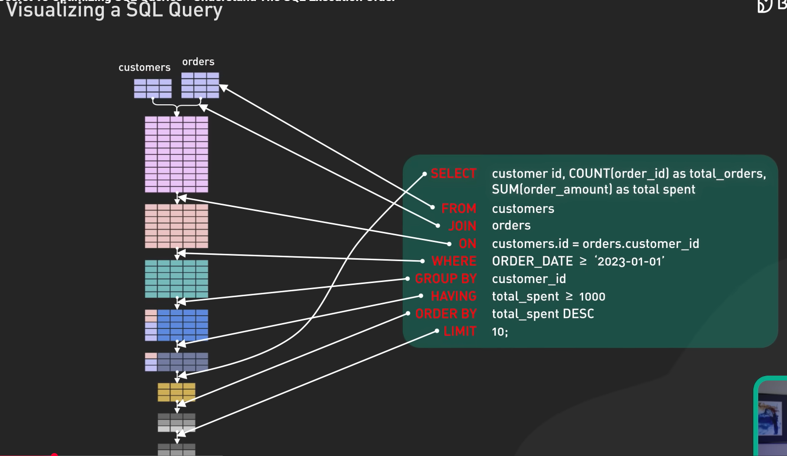

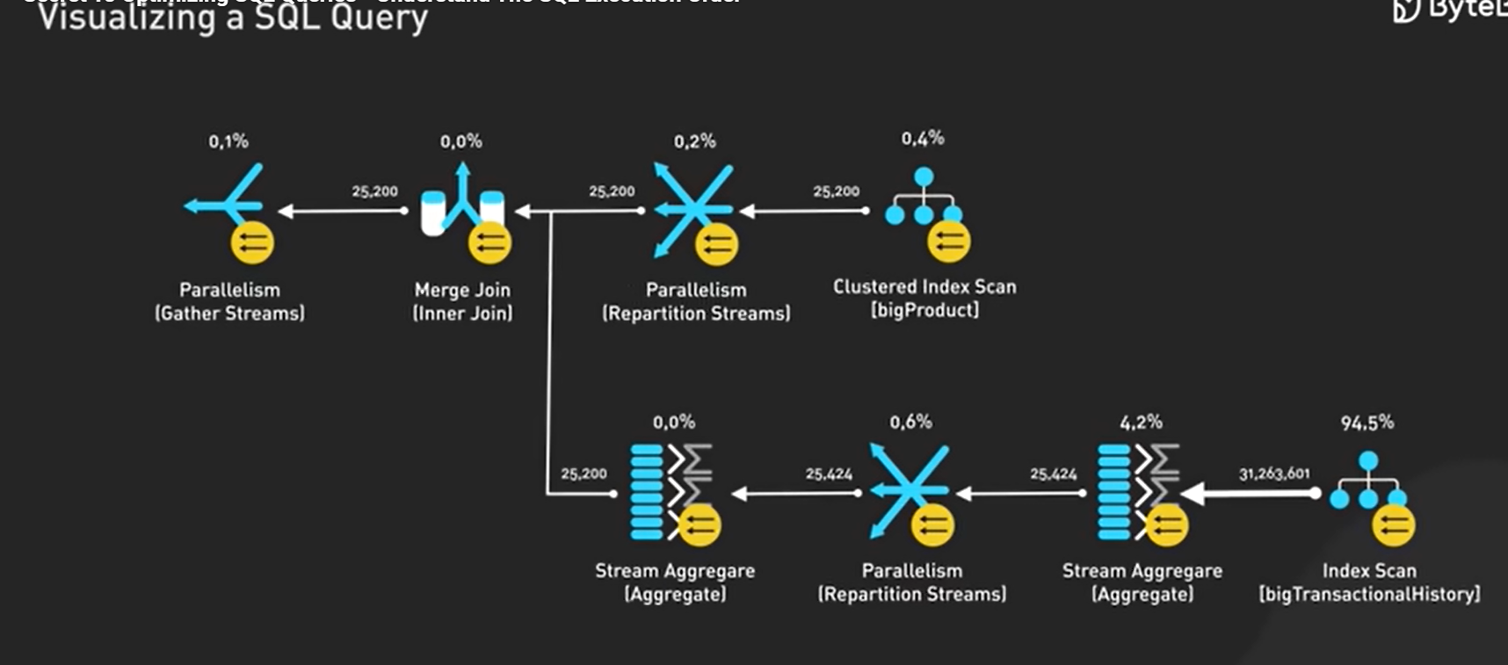



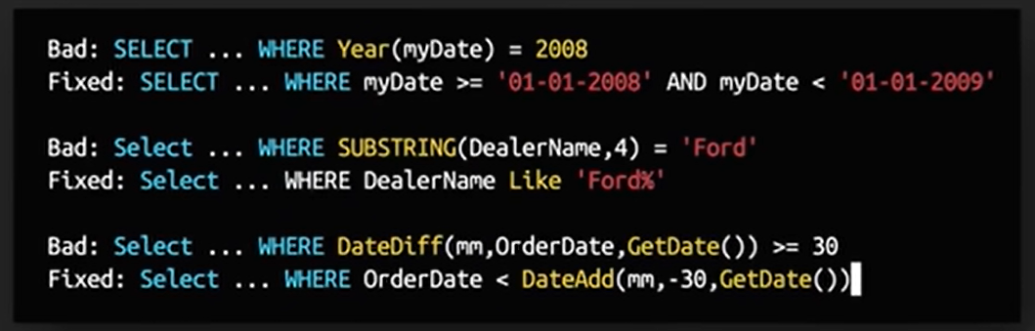

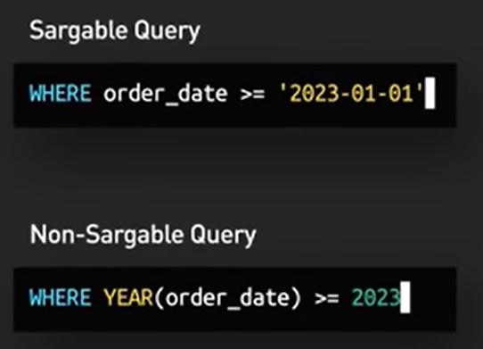



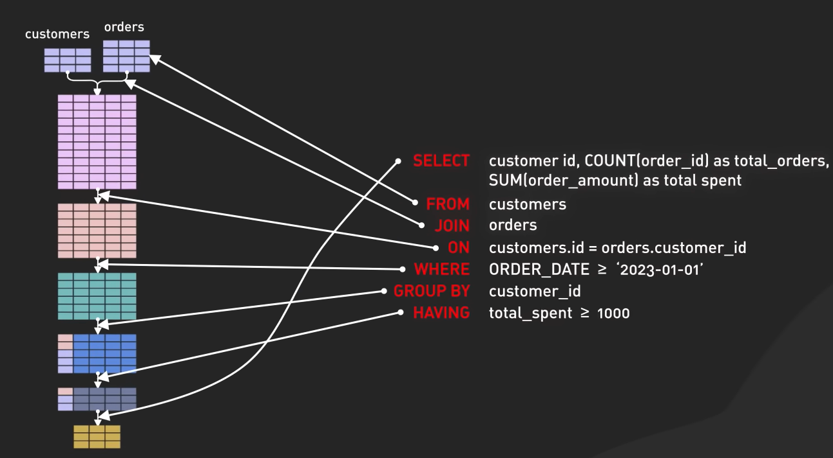


For optimizing, select covering indexing that includes all the column needed for the query, especially in select, where and join clauses, it enables database engine to retrieve values directly from the index. Indexing reduces i/o operation and minimizes performance overhead.

1-While optimizing order by and limit, consider using smaller result set.
2-Avoid sorting for larger dataset. Use indexing to sort the data in-memory.

